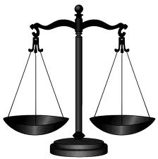
Unified New York Common Law Grand Jury
• PO Box 59; Valhalla, New York 10595 • Phone (845) 229-0044 • Fax (888) 891-8977

Lex Naturalis Dei Gratia
• Albany • Allegany • Broome • Bronx • Cattaraugus • Cayuga • Chautauqua • Chemung • Chenango • Clinton • Columbia
• Cortland • Delaware • Dutchess • Erie • Essex • Franklin • Fulton • Genesee • Greene • Hamilton • Herkimer • Jefferson
• Kings • Lewis • Livingston • Madison • Monroe • Montgomery • Nassau • New York • Niagara • Oneida • Onondaga
• Ontario • Orange • Orleans • Oswego • Otsego • Putnam • Queens • Rensselaer • Richmond • Rockland • Saint Lawrence
• Saratoga • Schenectady • Schoharie • Schuyler • Seneca • Steuben • Suffolk • Sullivan • Tioga • Tompkins • Ulster • Warren
• Washington • Wayne • Westchester • Wyoming • Yates

Psa 89:14 Justice and judgment are the habitation of thy throne: mercy and truth shall go before thy face.

February 25, 2014

Disclaimer - This is an open letter to the People, and to our public servants who took an oath to serve the People. The clerks have a sworn duty to protect Liberty (which presently rests on life support) and to deliver this memorandum to the recipients listed below. The press likewise has a duty to inform the People under the 1st amendment, to protect Liberty, and deliver this memorandum to the People. If the American Press continues to withhold from the People the facts they deserve to know and are necessary for the survival of a free people, then the press is no longer free or American. When the press has a duty to speak and they remain silent it is a wrongdoing.

Any orchestrated or deliberate interception of said communiqué is a dereliction of duty, conspiracy and obstruction of justice. The People have a right to know the truth and what their servants are doing. If your superiors try to intercept truth, you need to ask yourself why?

FROM: Unified New York Common Law Grand Jury
TO: Court Clerks,
Supreme Court Judges, (distributed to by court clerks)
Bailiffs, (distributed to by court clerks)
Sheriffs,
County Clerks
and the Good People of New York (distributed to by the press)

RE: Memorandum to Oath-takers, gate keepers of Justice - The purpose of these communiqués are to stimulate, inform, and provoke dialog among yourselves concerning Liberty, Justice, and your oath. And to inform you that the Common Law Grand Jury are just the People rising from the grassroots across the nation, from every walk of life, and that our only agenda is to return Justice, Honor, and Mercy into our judicial system.

America stands at the precipice and there are forces determined to push her into the abyss. Only the People can save America and it is the duty of the oath-takers to “understand” their oath and obey the “Law of the Land” and not the “un-constitutional orders of tyrants”. If “YOU” don’t know the constitution how can you keep your oath? We did not hire attorneys as our sheriffs and clerks, we hired one of the People, YOU!!!

Attached please find an article written about us by the Anti-Defamation League, and our answer to the same. I would like you to take note that the ADL article was non-substantive and all about name calling with absolutely no interest in what the People want or are doing. In contrast National Liberty Alliance’s substantive response offered an overwhelming amount of authorities and American principles by which we the People act.

There is an old saying, “you are what you eat” I would like to expand that to “you are what you think”. What do you think?

An America tomorrow depends upon “Your Honor Today”.

signed by order and on behalf of the 61 Unified Common Law Grand Jury’s of New York
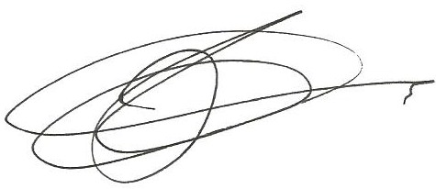

Common Law Grand Jury Administrator

LEX NATURALIS DEI GRATIA – Natural Law by the grace of God
1215AD – Year of the Magna Carta
Let us hear the conclusion of the whole matter: Fear God, and keep his commandments: for this is the whole duty of man. For God shall bring every work into judgment, with every secret thing, whether it be good, or whether it be evil. Eccl 12:13-14

JUSTICE. In the most extensive sense of the word, it differs little from virtue, for it includes within itself the whole circle of virtues.

